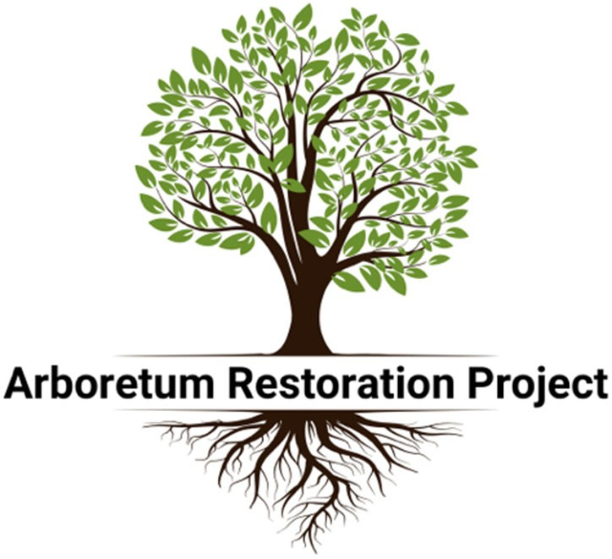

arbor-, (Latin: tree)
By definition, an arboretum is a place where trees and shrubs are cultivated for conservation, education, display, and preservation.

Originally funded by the Tulsa Garden Center in 1964, the Arboretum at Woodward Park is in need of restoration. By planting new trees, an investment in growth and sustainability for the Arboretum would ensure it reaches its full cultural and educational potential for future generations. Community leaders, residents, and all who love Woodward Park can invest in the Arboretum’s future through sponsoring a Tribute Tree to be planted in the Arboretum.

The plans for the project include the replacement of lost or dying tree specimens, expansion of the overall tree collection, and an irrigation system. The new irrigation system has been funded and work will begin on its installation in the coming months. Now is the time to select and sponsor a new tree in The Arboretum. We hope you will consider a contribution in support of the Arboretum while at the same time commemorating your family’s legacy within Woodward Park for years to come.

An Arboretum map and list of available trees (highlighted in green) are attached.

For questions or to inquire about other giving opportunities for Arboretum support, contact our
Director of Development, Jenna Garland, at (918) 576-5168 or jgarland@tulsagardencenter.org

Let’s Put Arbors Back in the Arboretum!

•

Name: _
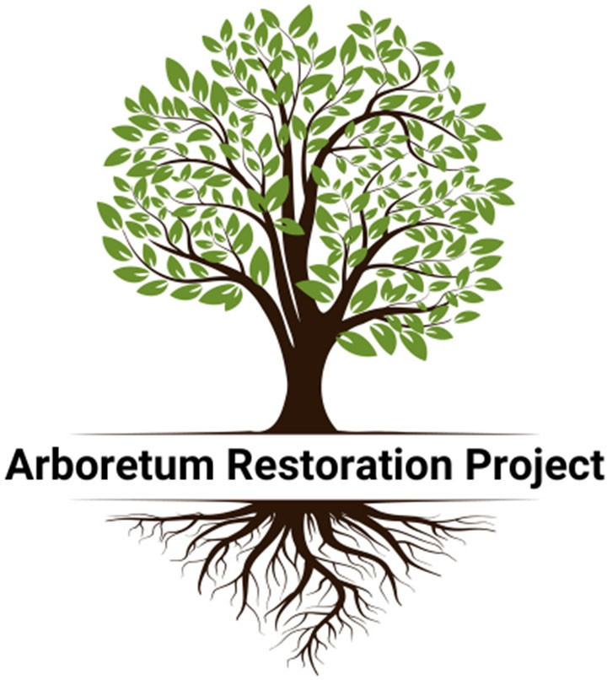
Address: _ Email: City: State: ZIP: Phone:

CC #:
Exp date: /
CVV: _

*Please make checks payable to the Tulsa Garden Center

Tribute Tree Sponsors - will be recognized with a plaque in the entrance of the Arboretum. Sponsorships cover costs associated with the purchase, installation, and general care of new or replacement trees. Sponsorships will be granted on a first-come, first-served basis.

State Champion specimen - $10,000
  - Dawn Redwood - SOLD
  - English Oak
  - Yellow Fruited American Holly
  - Japanese Pagoda Tree

New specimen - $2,500
  - American Smoketree - SOLD
  - American Sycamore - SOLD
  - Arizona Cypress
  - Chokeberry
  - Cornelian Cherry
  - Deciduous Holly (1)
  - Deciduous Holly (2)
  - Deodar Cedar - SOLD
  - Desert Willow
  - Eastern Redbud - SOLD
  - Escarpment Live Oak - SOLD
  - Golden Rain Tree -SOLD
  - Hedge Maple -SOLD
  - Kentucky Coffeetree - SOLD
  - Kousa Dogwood - SOLD

New specimen (cont’d) - $2,500
  - Northern Red Oak - SOLD
  - Paw Paw (1) - SOLD
  - Paw Paw (2) - SOLD
  - Paw Paw (3)
  - Persimmon (1)
  - Persimmon (2)
  - Persimmon (3)
  - Princeton Elm - SOLD
  - Red Buckeye - SOLD
  - Red Maple – SOLD
  - River Birch
  - Roughleaf Dogwood - SOLD
  - Sand Plum
  - Sassafras (1) - SOLD
  - Sassafras (2) - SOLD
  - Sassafras (3)
  - Shortleaf Pine
  - Slender Sweetgum
  - Smoketree - SOLD
  - Swamp Haw
  - Texas Buckeye - SOLD
  - Witch Alder

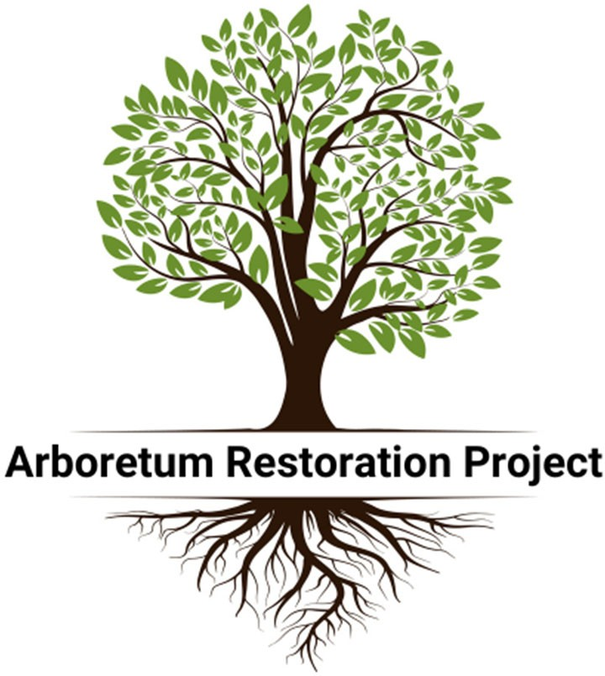

Each sponsorship plaque for Tribute Trees may include up to three lines of text. Each line of text must contain no more than 20 letters, spaces, and/or punctuation marks and be limited generally to the name and occasion of the tribute.

For questions or to inquire about other giving opportunities for Arboretum support, contact our
Director of Development, Jenna Garland, at (918) 576-5168 or jgarland@tulsagardencenter.org

